**Experiment 4**

***Aim*:** Find out the Minimum Cost Spanning Tree using Kruskal’s Algorithm with the help of the Greedy Approach.

**4.1 *Objective:***

Kruskal's algorithm: Kruskal’s algorithm finds the minimum spanning tree for a weighted connected graph G=(V,E) to get an acyclic sub graph with |V|-1 edges for which the sum of edge weights is the smallest.

**4.2 *Program Logic:***

A minimum spanning tree (MST) or minimum weight spanning tree is a subset of the edges of a connected, edge-weighted undirected graph that connects all the vertices together, without any cycles and with the minimum possible total edge weight.

|  |
| --- |
| 1. Algorithm Kruskal(E , cost, n ,t) 2. // E is the set of edges in G.G has n vertices. cost [u, v] is the 3 // cost of edge (u,v). t is the set of edges in the minimum-cost 4 // spanning tree. The final cost is returned. 5 {   6 Construct a heap out of the edge costs using Heapify; 7 for i :=1 to n do parent[i]:=-1; 8 // Each vertex is in a different set.   1. i :=0; mincost:=0.0; 2. while ((i< n-1) and (heap not empty)) do 3. { 4. Delete a minimum cost edge(u,v) from the heap 5. and reheapify using Adjust; 6. j :=Find(u); k :=Find(w); 7. if (j != k) then 8. { 9. i: =i+ l; 10. t [i, 1]:=u; t [i, 2]:=v; 11. mincost:=mincost+ cost[u, v]; 12. Union(j,k); 13. } 14. } 15. if (i!=n -1) then write ("No spanning tree”); 24 else return mincost; 16. } |

***4.3 Program Code:***

|  |
| --- |
| #include <stdio.h>  #include <conio.h> #include <stdlib.h>  int i, j, k, a, b, u, v, n, ne = 1; int min, mincost = 0, cost[9][9], parent[9]; int find(int); int uni(int, int); void main()  { printf("Enter the no. of vertices:\n"); scanf("%d", &n); printf("\nEnter the cost adjacency matrix:\n"); for (i = 1; i <= n; i++)  {  for (j = 1; j <= n; j++)  {  scanf("%d", &cost[i][j]); if (cost[i][j] == 0) cost[i][j] = 999;  }  }  printf("The edges of Minimum Cost Spanning Tree are\n"); |

|  |
| --- |
| while (ne < n)  { for (i = 1, min = 999; i<= n; i++)  { for (j = 1; j <= n; j++)  { if (cost[i][j] < min)  { min = cost[i][j]; a = u = i; b = v = j;  }} } u = find(u); v = find(v); if (uni(u, v))  {  printf("%d edge (%d,%d) =%d\n", ne++, a, b, min); mincost += min;  }  cost[a][b] = cost[b][a] = 999;  }  printf("\nMinimum cost = %d\n", mincost); getch(); } int find(int i)  { while (parent[i]) i = parent[i]; return i; |
| } int uni(int i, int j)  {  if (i != j)  { parent[j] = i; return 1;  } return 0;  } |

***4.4 Conclusion:***

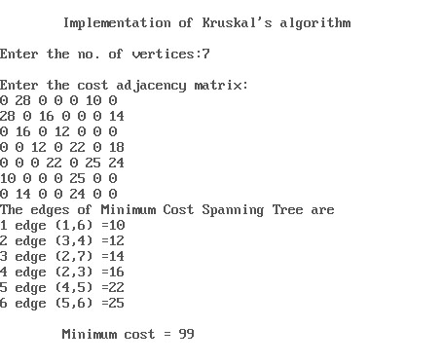

***4.5 Analysis:***

The time complexity of Kruskal’s Algorithm = O(ElogV) or O(ElogE). where e is the number of edges and v is the number of vertices.